CONGRATULATIONS TO OUR 2023 SCHOLARSHIP RECIPIENTS
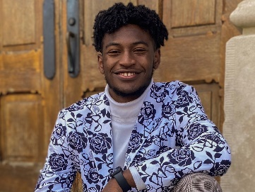

Calvin Bell is a student at Morehouse College. He has served his school and community as a Cory Booker Congressional Intern, as a recipient of the Maurice Washington Emerging Leader Scholarship, as a Morehouse Student Government Senator, a Howard Thurman Honor, Editor –in-Chief of Litteritus, as President of the Omicron Delta Kappa Honors Society, as a Morehouse Quiz Bowl team member, as a member of the Glee Club, and Rugby Team. He volunteers at Parkside United Methodist Church, at Common Good Atlanta, the Atlanta Science Festival, the Promise Center, and at the Herman Russell West End Academy.

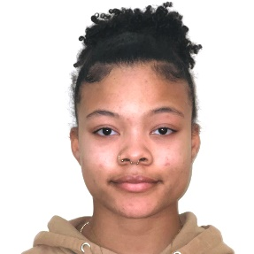

Brooklyn Farmer is a student at Fisk University. She has served her school and community as a Student Ambassador as Vice President, as a United Negro College Fund Student Ambassador, as a Resident Assistant. She is a Mellon-Mays Fellow, as has received the WEB DuBois Honor. She is a Crystal Bridges Curatorial Intern and volunteers at Nashville’s Summer Fest

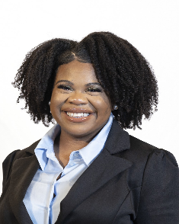

Shauniece Frazier is a student at Spelman College. She is a Mellon Mays Fellow, a Peer Assistant Leader, as serves on the Transfer Student Union. She is a Peer Assistant Leader, and a Churchome Youth Leader. Shauniece also owns a non-profit.

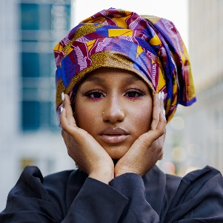

Oumou Kaba is a student at Clark Atlanta University. As Miss Sophomore she hosted monthly workshops and events on African Culture. She has continued sot sere her school and community as a Breaking the Cycle Project Manager, as a member of the Royal Court of the Atlanta University Center African Student Association, as Chair of the International Awareness and Involvement Committee of Delta Sigma Theta Sorority, as a Brand Ambassador for CAU Panthers Abroad, and as Vice President of the African Student Association.
Oumou is a Community Activist. She testified against Department of Education’s lack of Title IX Coordinators, marched for Eric Garner, and participated in protest to shut down the Art Shack in Brooklyn for racist art.

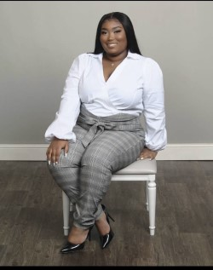

Ivoryana Neal is a student at Spelman College. She serves her school and community as an Assistant to Senator Kimberly Lightfoot, as a member of the Spelman Debate Team, and as a police intern.

